**Search Engine Optimization (SEO)**

Recently Next.js has also their new metadata API and provided us with 2 new ways of managing meta data:

1. Static Metadata
2. Dynamic Metadata

**Static Metadata:**

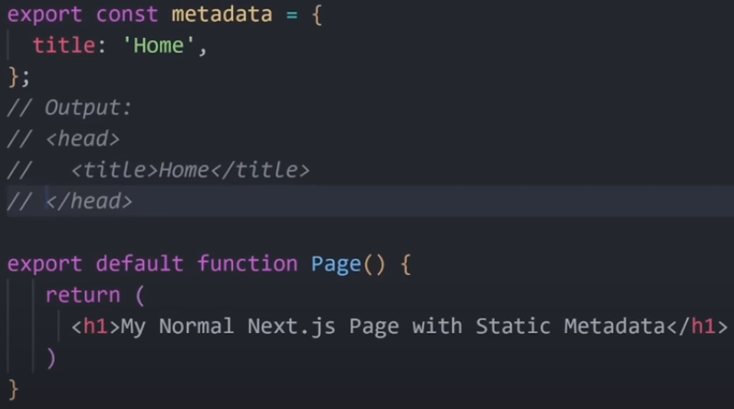

**Dynamic Metadata:**

